Use the internet and/or books to find the cause of the following disasters
NAME:
Class:
Disaster | Disaster Description
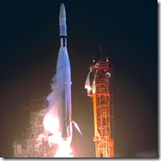 | 1962  The Mariner 1 rocket with a space probe headed for Venus diverted from its intended flight path shortly after launch. Mission Control destroyed the rocket 293 seconds after lift off
CAUSE

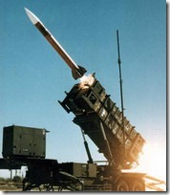 | 1991  During the first Gulf War, an American Patriot Missile system in Saudi Arabia failed to intercept an incoming Iraqi Scud missile. The missile destroyed an American Army barracks.
CAUSE

Disaster | Disaster Description
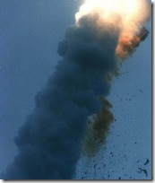 | 1996  Ariane 5, Europe’s newest unmanned rocket, was intentionally destroyed seconds after launch on its maiden flight. Also destroyed was its cargo of four scientific satellites to study how the Earth’s magnetic field interacts with solar winds.
CAUSE

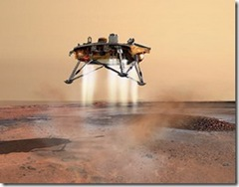 | 1998  After a 286-day journey from Earth, the Mars Climate Orbiter fired its engines to push into orbit around Mars. The engines fired, but the spacecraft fell too far into the planet’s atmosphere, likely causing it to crash on Mars..
CAUSE

